SECTION 9 PARKING AND LOADING

9.1.0 GENERAL
The principal design objectives for any parking facility are the provision of safe customer service and convenience coupled with minimal interference to street traffic flow. Specific ordinance requirements for parking facilities and required parking calculations are provided in the LDC. The requirements for parking facilities are dependent on a site's zoning, principal uses, and accessory uses. Depending on zoning and land use, parking minimums, maximums, or prohibitions may apply and shall be determined by the LDC.
The following criteria aid in designing parking facilities in conformance with accepted principles of traffic engineering and safety. The following criteria address requirements for off-street parking design and general principles for on-street parking placement within the right-of-way. Loading zones are also addressed for both on-street and off-street facilities in this Section. Various components of parking areas both within the right-of-way and on public or private properties are defined in Figure 9-1.
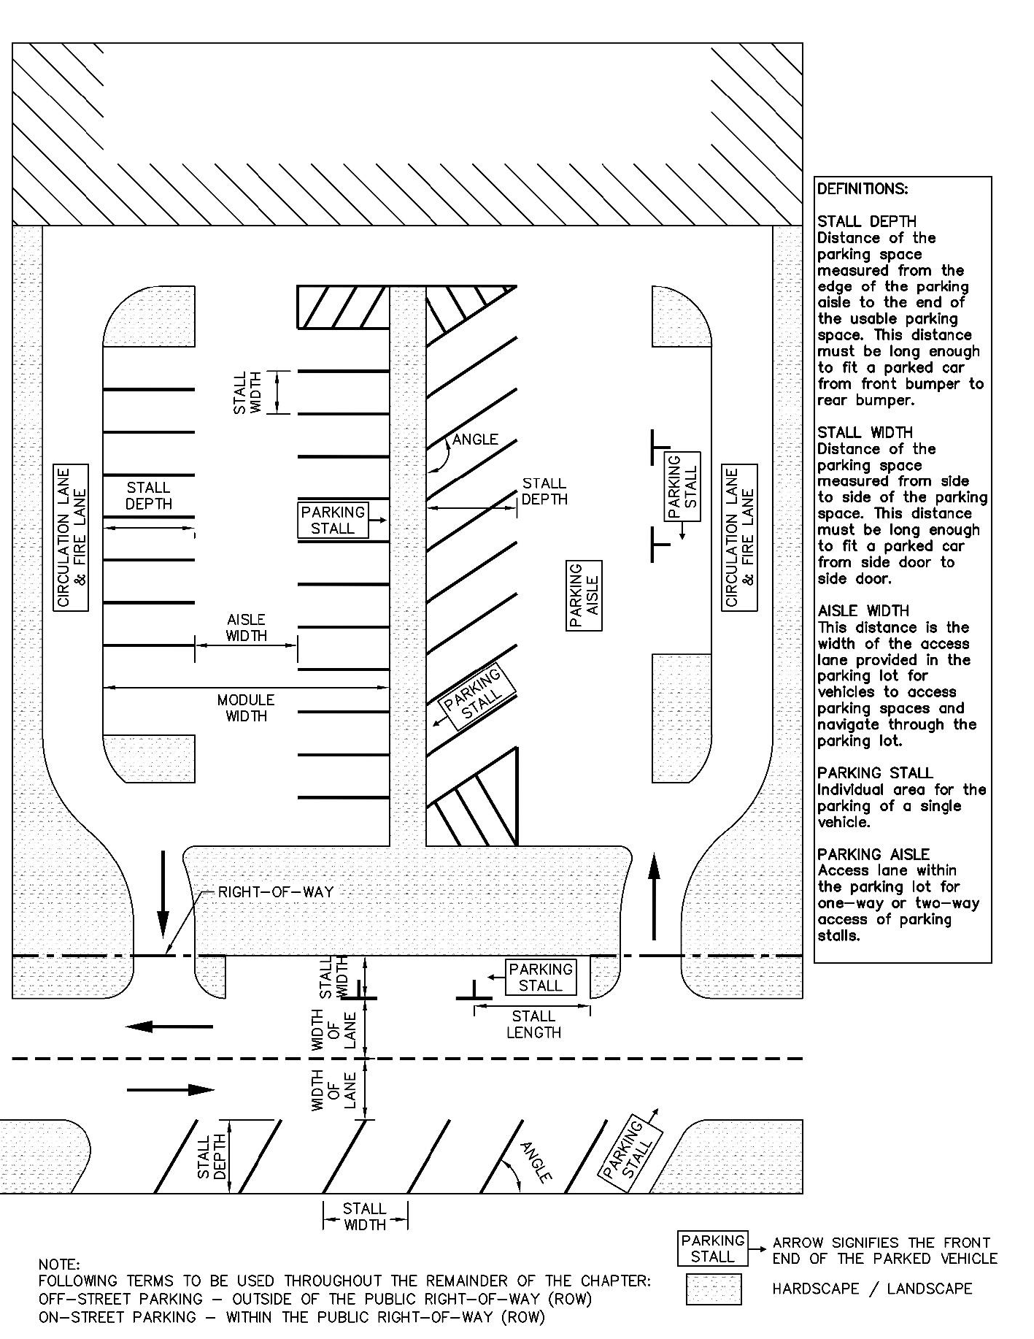
Figure 9-1 — Parking Overview

9.2.0 PARKING DESIGN (ON-STREET)
Parking is defined as on-street parking when it has direct access to vehicular travel lanes in the right-of-way. Stationary vehicles parked along the corridor act as a speed management technique in appropriate contexts, per Section 3.3.3.1. On-street parking can facilitate the application of bulb-outs, which can reduce motor vehicle speeds, reduce impervious cover, allow for additional street trees, and reduce pedestrian crossings.
A. Where on-street parking is desired without adequate right-of-way, a dedication of right-of-way shall be required.
B. On-street parking shall not count towards required parking unless it is approved by the City Transportation Engineer or applicable Director.
1. On-street parking counted towards parking requirements remain open to the public and may not be reserved for sole usage of the adjoining development.
2. The adjacent on-street parking may be removed at any time for any reason and the developer counts the spaces at their own risk. There will be no compensation for the removal of on-street parking, commercial zones, or loading areas.
C. Pavement design for any on-street parking shall be consistent and compatible with the general street structure. This will most often be the same cross section as the surrounding pavement; however, it may have a different design recommended which must be approved based on its projected use. Any such pavement must comply with Section 14 Pavement Design.

9.2.1 ON-STREET PARKING TYPES
On-street parking may be provided as parallel or back-in angle parking. Parallel parking shall be the configuration of all on-street parking unless approved by the City Transportation Engineer or applicable Director. Parking is not permitted on Level 4 Streets. Head-in angled parking is prohibited as an on-street parking type.
The following are descriptions of the types of on-street parking configurations:
a) Parallel - Side of the vehicle is parallel to the curb when parked.
b) Angle (Back-In) - Vehicle backs into the stall at an angle to the roadway.

9.2.1.1 On-Street Parking Alternate Space Uses.
A. On-street parking can be converted to sidewalk cafes or street patios for use by adjacent properties, at the request and expense of the adjacent property owner and by approval of the City Transportation Engineer or applicable Director. Reference Sidewalk Café and Street Patio Handbooks for more information on design of these facilities and the Standards Manual. A license agreement is required for a parklet for maintenance by the adjacent property owner. Parklets serve as an extension of the pedestrian zone by providing a protected space for pedestrian use or as a sidewalk cafe. Reference Sidewalk Café and Street Patio Handbooks for more information on design of these facilities and the Standards Manual.
B. On-street parking spaces may be converted to bike or dockless mobility parking spaces with approval by the City Traffic Engineer, applicable Director, or their designee. Refer to Section 9.8.0 for bicycle parking and Section 9.9.0 for dockless mobility parking criteria.
C. To enhance the pedestrian zone and safety of the bicycle and street edge zone, street trees and landscape elements can be provided in bulb-outs, if sight distance is maintained at intersections and horizontal and vertical clearances for landscaping are maintained per Section 11 of this manual.

9.2.2 GENERAL DESIGN CRITERIA
For the following on-street parking design criteria, if there are conflicts between the Land Development Code, Building Code, Fire Code, or this Section, the stricter shall apply:
A. On-street parallel parking stalls width shall be measured from the edge of the traveled way to the face of curb. The combination of travel and parking stall next to one another shall be no less than 18 ft. In areas adjacent to transit routes, the minimum shall be 19 ft. Parking is assumed to be 8 ft. in width.
B. On-street angled parking stalls shall be 8.5 ft. minimum width, measured from center of stripe or face of curb.
C. Individual parallel parking stall lengths shall be 20 ft. in length.
D. On-street parking is only permitted in cul-de-sac areas where demonstrated control vehicle can make turns without conflicting with parked cars. Refer to Section 3.4.2.2 for criteria on culs-de-sac.
E. On-street angled parking shall be constructed in accordance with the dimensions in Table 9-1.
F. A construction joint shall be provided on concrete roadways to delineate the parking lane edge.
G. On-street parking shall be prohibited on streets with target speeds 35 mph or greater.
H. If the sidewalk abuts the end of the angled parking stall, a 2 ft. overhang shall not be counted towards the required clear width for sidewalks.
I. On-street parking shall not be placed on Level 4 or Level 5 facilities.
J. Except for streets that specify on-street parking in the Street Network Table in the ASMP, right-of-way shall be dedicated by applicant for on-street parking at the applicant's request.
K. On-street parking shall be the lowest priority when determining the roadway cross section. Due to the large variance in right-of-way required between the two parking types, angled parking shall only be allowed if all other right-of-way zone elements are included with their minimum widths being met.
L. Accessible parking shall meet current PROWAG and Texas Accessible Standards (TAS).
M. Time-Restricted On-Street Parking - These are considered 5-minute standing zones. Vehicles shall have their hazards lights flashing and always be attended by the driver. These are allowed on Level 0, 1, 2, and 3 Streets in specifically designated spaces. Time limits shall be signed for these spaces and conform to City of Austin Standards and be approved by the City Traffic Engineer, applicable Director or their designee.
Table 9-1 — Minimum Dimensions for Angled On-Street Parking Stalls
Angle | Stall Width | Stall Depth (Perpendicular to Curb) | Minimum Width of Adjacent Lane | Curb Overhang
45 | 8 ft.—6 in. | 17 ft.—8 in. | 12 ft.—8 in. | 2 ft.
50 | 8 ft.—6 in. | 18 ft.—3 in. | 13 ft.—3 in. | 2 ft.
55 | 8 ft.—6 in. | 18 ft.—8 in. | 13 ft.—8 in. | 2 ft.
60 | 8 ft.—6 in. | 19 ft.—0 in. | 14 ft.—6 in. | 2 ft.
65 | 8 ft.—6 in. | 19 ft.—2 in. | 15 ft.—5 in. | 2 ft.
70 | 8 ft.—6 in. | 19 ft.—3 in. | 16 ft.—6 in. | 2 ft.

9.2.3 ON-STREET PARKING PLACEMENT
On-street parking and bike lanes make up the bicycle and street edge zone, as outlined in Section 2. Where both are present along the same corridor, their placement in relation to each other defines the operations and safety for each user within the bicycle and street edge zone. Users of bicycle facilities are to be given the priority over vehicles within this zone. Elements typically placed in the pedestrian zone can be extended into the bicycle and street edge zone (e.g. street trees, bike racks) in strategic locations to intermix the two zone uses which can have a positive effect on the feel and usage of the street.

9.2.3.1 General Placement Criteria.
A. A 1.5 ft. offset from the curbside of a parking stall shall be provided to all obstructions such as parking meters, poles, trees, etc.
B. Parking shall be prohibited within 15 ft. of either side of fire hydrants. Refer to Figure 9-2.
C. The nearest edge of a parking stall shall be a minimum of 30 ft. from the curbside of a crosswalk. Refer to Figure 9-2.
D. The nearest edge of a parking stall shall be a minimum of 30 ft. from the approach to an intersection. Intersections do not include driveways.
E. Texas Transportation Code 545.302 specifies prohibitions for parking of vehicles. Figure 9-3 illustrates spacing from a controlled intersection with a crosswalk.
F. If transit service is provided, no parking shall be permitted in the platform areas as defined in Section 6 of this manual to allow for loading and unloading of passengers.
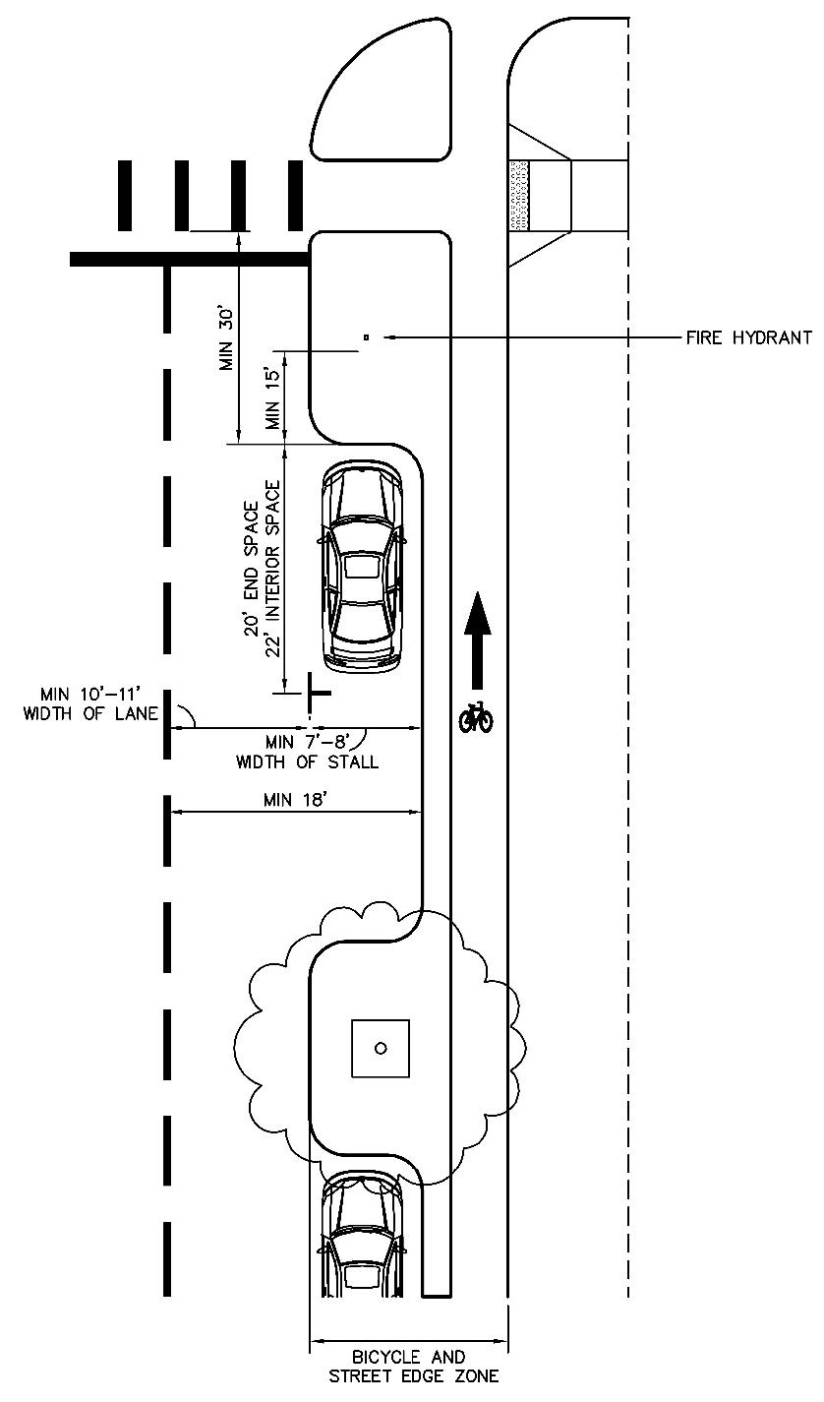
Figure 9-2 — Bulb-out Usage and Parking Placement

9.2.3.2 Bike Lane Interactions with Parking and Loading.
Figures 9-3 through 9-6 below illustrate proper placement of bike lanes, on-street parking stalls and on-street loading stalls when included on the same street. The figures below illustrate the treatment of protected and buffered bike lanes as well as bike lane transitions for recessed loading stalls.
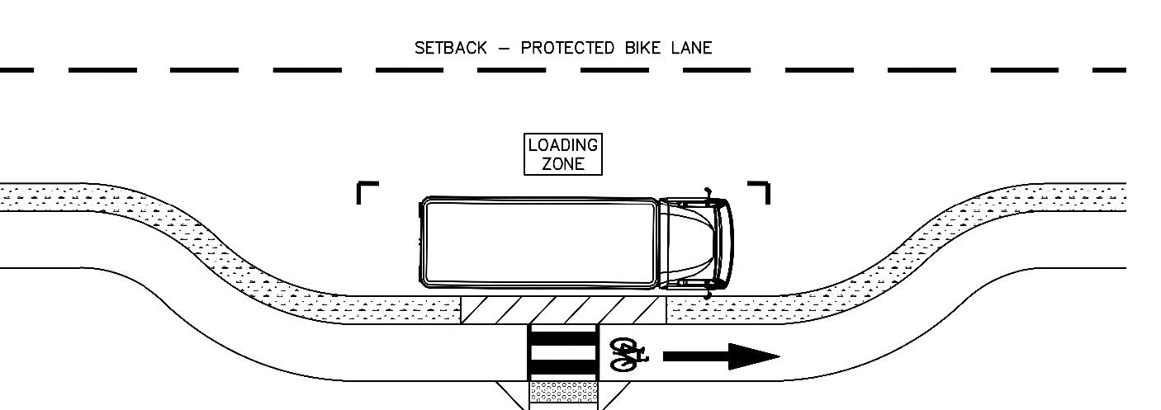
Figure 9-3 — Protected Bike Lane with no On-Street Parking
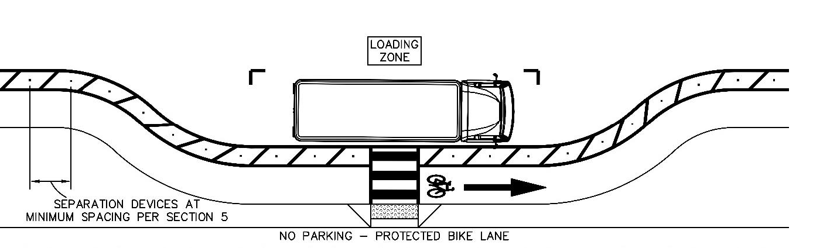
Figure 9-4 — Buffered Bike Lane with No On-Street Parking
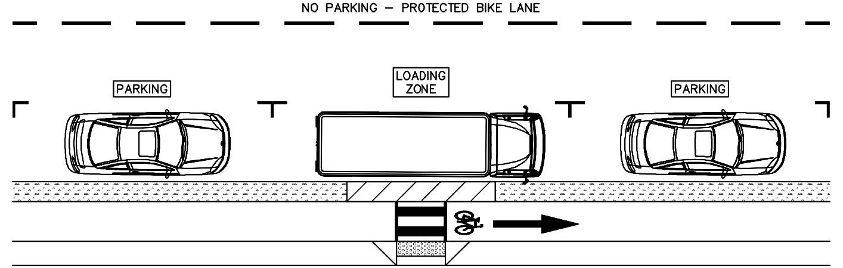
Figure 9-5 — Protected Bike Lane with On-Street Parking
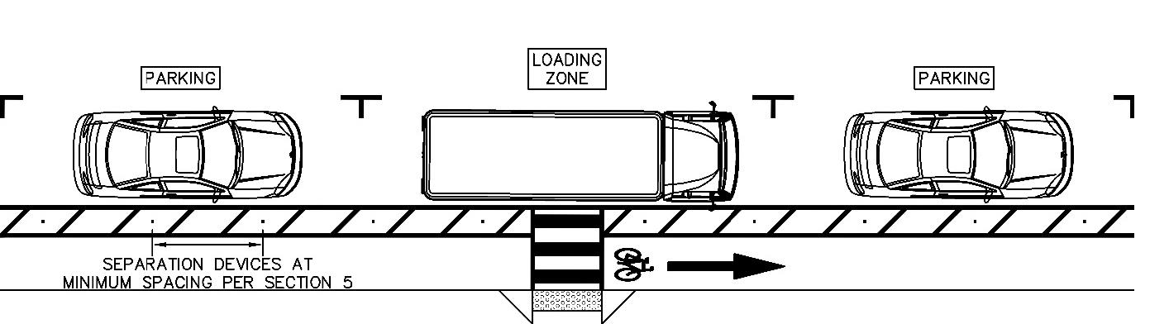
Figure 9-6 — Buffered Bike Lane with On-Street Parking
A. A minimum 3 ft. buffer shall be provided between the edge of parallel on-street parking and a bike lane. The buffer ensures that opening car doors will not encroach in the protected bike lane.
B. Protected or buffered bike lanes with vertical separation elements in the buffer shall be provided on the pedestrian zone side of on-street parking.

9.3.0 PARKING DESIGN (OFF-STREET)
Parking is defined as off-street parking when it is placed outside of the public right-of-way (refer to Figure 9-1).

9.3.1 OFF-STREET PARKING TYPES
A. Parallel - Side of the vehicle is parallel to the curb when parked.
B. Angle (Head-In) - Front of the vehicle pulls into the front of the parking stall at an angle.
C. Perpendicular - Front or back of the vehicle is 90 degrees to the parking aisle.

9.3.2 GENERAL DESIGN CRITERIA
A. Parking stalls shall be constructed in accordance with the dimensions in Table 9-2 for surface parking and with dimensions in Table 9-3 for structured parking.
B. Compact parking stalls shall not exceed 30% of the required parking spaces for a site. Compact parking stalls may be used for additional parking provided beyond the minimum parking required, after all parking reductions have been accounted for.
C. Parking stalls may only be installed in 100-year or 25-year floodplains if the requirements of LDC are met.
D. For parking structures, columns may encroach into the head end of parking stalls, provided that the columns do not reduce the total (double-loaded) module width by more than 2 ft. and the columns do not encroach into more than 25% of the spaces. Columns may not encroach into the side of parking stalls; stall width must be measured from the face of the column.
E. The angle and design of parking stalls and aisles shall be relatively consistent throughout a unified development. If both structured parking and surface parking exist in a development, the angle and design of parking stalls shall be consistent within the structured parking and consistent within the surface parking. One-way angled parking aisles shall be designed to alternate the direction for adjacent aisles. Proper signs and markings shall be required to reinforce traffic circulation and flow.
F. Each parking stall shall be independently accessible and shall have a vertical clearance as specified in the Building Criteria Manual.
G. Tandem parking stalls (one car behind another, so that one car must be moved before the other can be accessed) are allowed for residential uses and for commercial uses that operate exclusively as a valet service following requirements of Chapter 13-5 of the City Code. Tandem parking is also allowed for additional parking provided in excess of the required parking, after reductions applied, for employees only working the same shift and shall be signed and marked as employee parking only. Both stalls in tandem must be standard size per Table 9-2; no compact or accessible tandem stalls are permitted. When tandem parking stalls are provided for residential uses, the following must be included as a note on the site plan:
1. The stalls must be reserved and assigned to dwelling units which are required to have two or more parking stalls per unit (i.e. units with two or more bedrooms).
2. At least one of the stalls must be located within an enclosed garage or carport for residential uses with four or fewer dwelling units.
3. When the residential use includes 10 or more parking stalls, except in the downtown area as defined in Figure A-2 and for structured parking garages, at least 10% of the total parking stalls on the site must be unassigned stalls which are available for the use of visitors, shall not be in tandem, and do not count towards the total parking required after all parking reductions are applied.
H. Each parking and loading stall shall have adequate drives, aisles and turning and maneuvering areas for access and usability.
I. Parking and loading facilities accessed from a low volume, high volume, or temporary driveway approach shall be surfaced and maintained with asphaltic concrete or other permanent hard surfacing material sufficient to prevent mud, dust, loose material, and other nuisances. Materials may allow for infiltration of stormwater but must be included as impervious cover. For lots at least one acre in size, gravel surfacing is permitted for a single-family residence. With the approval of the City Transportation Engineer or applicable Director gravel surfacing may be permitted in other locations when deemed necessary to protect trees.
1. In such cases, the gravel surfacing must be limited to parking stall areas within the critical root zone of the trees and must be confined by curbing or other barriers to prevent it from being carried into public roadways and drainageways. Gravel surfacing will not be permitted on slopes greater than 5%, within accessible parking spaces, or along accessible pathways between accessible parking and the building entry. Gravel used for parking must be crushed, angular stone, with a minimum ¾ in. aggregate size, and must be included as impervious cover.
J. Safety barriers, fencing, wheel stops, curbs or other restrictive barriers and directional markers shall be provided to assure safety, efficient utilization, protection to landscaping and to prevent encroachment onto adjoining public or private property.
K. No more than 10 percent of all the stalls should be located in the service areas at the rear of shopping centers and other locations with poor pedestrian access to the building entrances.
L. Visibility of and between pedestrians, bicyclists and motorists shall preserved when circulating within a parking facility and when entering and exiting a parking facility. Landscaping and other objects within the parking lot shall remain outside of the visibility sight triangle. Refer to Section 3.4.2.1.1 for sight triangle criteria.
M. At least 40% of the required parking stalls at land uses with fueling stations shall be stalls which do not abut air, water, or vacuum facilities.
N. Design speed for internal circulation routes in parking lots or structures shall be 10 mph or less and accommodate a SU-40 design vehicle for all turns.
O. Parking bays (rows of parking spaces separated by parking tree islands) shall be no more than 200 ft. in length or 20 parking stalls long, whichever is less. Cross-aisles or turnarounds should be provided in order to avoid long dead-end aisles. This criteria does not apply to structured parking.
P. End islands should be used to delineate primary traffic aisles and to protect cars parked at the end of parking bays from turning vehicles. Concrete islands in lieu of painted areas should be provided in order to prevent vehicles from parking in such areas and thereby obstructing sight distance triangles. Refer to Figure 9-7 for perpendicular parking and Figure 9-8 for angled parking end island configurations. This criteria does not apply to structured parking.
Q. Accessible parking stalls shall meet current PROWAG and Texas Accessible Standards (TAS).
R. Accessible parking stalls shall be located on the shortest accessible route of travel from adjacent parking to an accessible building entrance. Accessible parking stalls shall be dispersed among the various types of parking facilities provided. In parking facilities that do not serve a building, accessible parking stalls shall be located on the shortest route to an accessible pedestrian entrance to the parking facility. Where buildings have multiple accessible entrances with adjacent parking, accessible parking stalls shall be dispersed and located near the accessible entrances.
S. Parking spaces within an automotive repair facility or service station may be counted as required parking spaces as long as they are independently accessible.
T. Traffic control signs and marking used in parking areas, except for structured parking garages, must conform to the latest edition of the Texas Manual for Uniform Traffic Control Devices (TMUTCD).
U. If a site is located along a Corridor, as defined in the LDC, off-street parking shall not be placed between the building façade and the Corridor per LDC.
V. Refer to the LDC for landscape requirements in parking lots.
W. Refer to LDC for the required number of accessible parking stalls for a site.
X. Refer to the LDC for allowed use of off-site parking to satisfy off-street parking requirements.
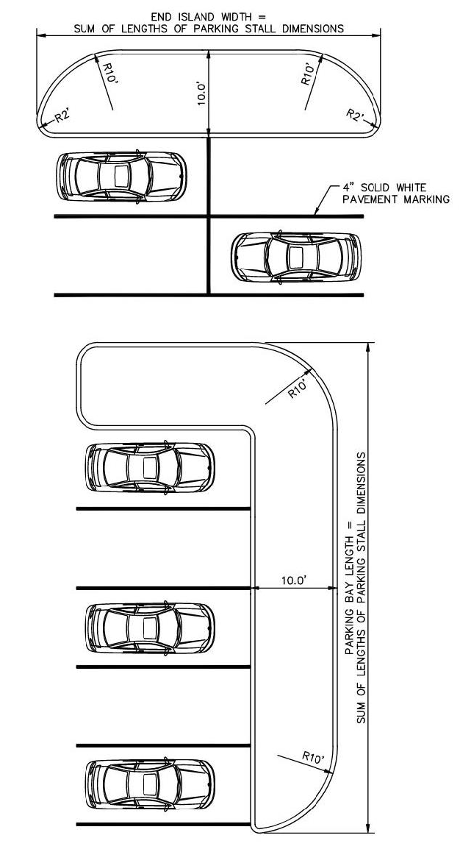
Figure 9-7 — Typical Parking Bay and End Island Geometry for Perpendicular Surface Lot Parking
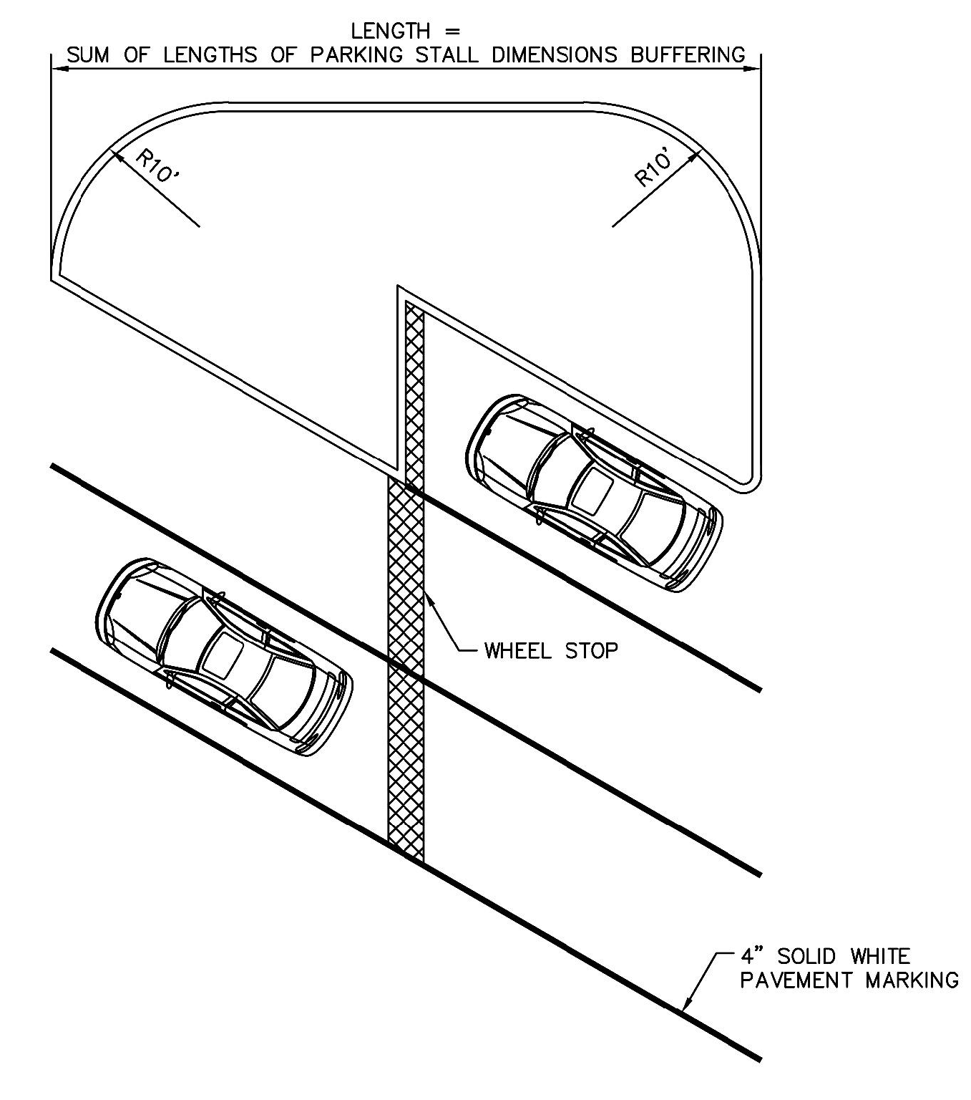
Figure 9-8 — Typical End Island Designs for Angled Surface Lot Parking
Table 9-2 — Surface Lot Parking Criteria
Angle of Parking (degrees) | Width of Stall | Depth of Stall 90° to Aisle | Width of Aisle |  | Module Width
Angle of Parking (degrees) | Width of Stall | Depth of Stall 90° to Aisle | One Way | Two Way | Module Width
Standard Parking Stalls
30 | 8 ft.—6 in. | 16 ft. | 12 ft. | - | Depth of Stall + Width of Aisle.
45 | 8 ft.—6 in. | 17 ft. | 14 ft. | - | Depth of Stall + Width of Aisle.
60 | 8 ft.—6 in. | 18 ft. 6 in. | 16 ft. | - | Depth of Stall + Width of Aisle.
75 | 8 ft.—6 in. | 18 ft. 6 in. | 18 ft. | - | Depth of Stall + Width of Aisle.
90 | 8 ft.—6 in. | 17 ft. 6 in. | - | 25 ft. | Depth of Stall + Width of Aisle.
Compact Parking Stalls
45 | 7 ft.—6 in. | 15 ft. 11 in. | 13 ft. | 18 ft. | Depth of Stall + Width of Aisle
60 | 7 ft.—6 in. | 16 ft. 8 in. | 18 ft. | - | Depth of Stall + Width of Aisle
75 | 7 ft.—6 in. | 16 ft. 6 in. | 18 ft. | - | Depth of Stall + Width of Aisle
90 | 7 ft.—6 in. | 15 ft. | - | 18 ft. | Depth of Stall + Width of Aisle
Parallel Parking Stalls
0 | 8 ft.—6 in. (Width) | 22 ft. (Length) | 12 ft. 6 in. | 25 ft. | -

Table 9-3 — Structured Parking Criteria
Angle of Parking (degrees) | Width of Stall | Depth of Stall 90° to Aisle | Width of Aisle |  | Module Width
Angle of Parking (degrees) | Width of Stall | Depth of Stall 90° to Aisle | One Way | Two Way | Module Width
Standard Parking Stalls¹
30 | 8 ft.—6 in. | 16 ft. | 11 ft. | - | Depth of Stall + Width of Aisle
45 | 8 ft.—6 in. | 17 ft. | 13 ft. | - | Depth of Stall + Width of Aisle
60 | 8 ft.—6 in. | 18 ft. 6 in. | 15 ft. | - | Depth of Stall + Width of Aisle
75 | 8 ft.—6 in. | 18 ft. 6 in. | 17 ft. | - | Depth of Stall + Width of Aisle
90 | 8 ft.—6 in. | 17 ft. 6 in. | - | 24 ft. | Depth of Stall + Width of Aisle
¹ Compact Parking Stalls per Table 9-2 may be used in Structured Parking.

9.3.3 PEDESTRIAN PATHS FROM PARKING AREAS

9.3.3.1 Accessible Routes.
A. Refer to LDC for required number of accessible parking spaces.
B. Pedestrian accessible routes are clear and unobstructed paths provided on a site that meet all Public right-of-way Accessibility Guidelines (PROWAG) as well as the current Texas Accessibility Standards (TAS). An accessible route shall be located so that a person using the route is not required to travel in a traffic lane or behind a parked vehicle (except the vehicle the person operates or in which the person is a passenger). Refer to Section 4.1.8 for specific requirements for accessible routes.

9.3.3.2 Pedestrian Parking Paths General Criteria.
In order to provide parking facilities that are conducive to pedestrian safety, pedestrian parking paths shall be provided that do not require a person using the route to travel in a traffic lane or behind a parked vehicle (except the vehicle the person operates or in which the person is a passenger). These can be accomplished through the use of optional landscape medians as well as providing perimeter sidewalks around the edge of a surface parking lot. These criteria do not apply to structured parking garages.
A. A pedestrian parking path shall be provided for 50% of on and off-street parking and loading facilities. Accessible routes shall be provided to every accessible parking stall.
B. Accessible routes terminating at a parking lot shall be accessible by every accessible parking stall and pedestrian loading zone provided in the parking lot.
C. Accessible routes shall be shown with circulation direction arrows and limits clearly defined on all submitted site plans for review by the applicable city review department.
D. Provided accessible routes shall be clear to all individual users of a parking lot. The accessible route shall be a clear path for exiting the parking lot. If the route is not clearly identified and recognizable to all individuals exiting the parking lot, it shall be identified using pavement markings and signage at the discretion of the applicable city review department.
E. Accessible routes serving accessible parking stalls shall be clearly marked with the use of cross hatched pavement markings. The extents of the route from the accessible parking to the termination at the accessible elements on the site shall be delineated with cross hatched pavement markings. Refer to Figure 9-9.
F. Accessible routes serving accessible parking stalls shall be placed along one side of the accessible parking stall to allow the unobstructed loading and loading of passengers. Refer to Figure 9-9.
G. Bike paths shall not be used as an accessible route.
H. Pedestrian parking paths that do not serve accessible parking spaces may be composed of alternative surface materials that are not smooth or ADA compliant such as crushed granite.
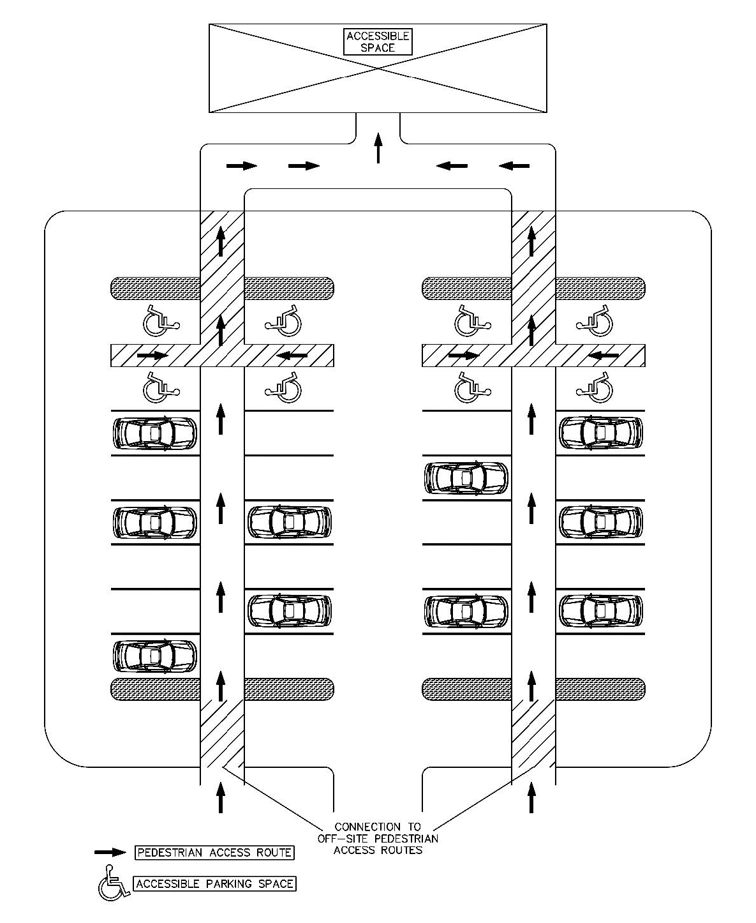
Figure 9-9 — Desired Pedestrian Parking Paths Layout

9.3.3.3 Design Strategies.
The criteria set forth in this Section shall be followed for all design of pedestrian parking paths. Listed below are several design strategies that shall be evaluated to counteract negative conditions affecting pedestrian safety along pedestrian parking paths. These strategies shall be evaluated for existing conditions as well as conditions that are forecasted to occur after parking is open for operation.

9.3.3.3.1 Raised Crosswalks.
In parking lots with commercial or retail land uses where internal circulation routes do not encounter a stop sign for distances of 200 ft. or greater, raised crosswalks shall be used to cross the internal circulation lanes to improve the visibility of pedestrians and slow down traffic.

9.3.3.3.2 Pavement Markings.
Where pedestrian parking paths cross internal circulation lanes, crosswalk markings shall be used that are high visibility continental or "ladder" style and be accompanied by pedestrian crossing warning signs per the TMUTCD, latest edition. By outlining the pedestrian path within the parking lot, pedestrians can be deterred from walking directly in areas that experience high vehicle conflicts.

9.3.3.3.3 Create Buffers.
In parking lots that experience high turnover of vehicles and high volumes of traffic, providing the pedestrian route between parked cars creates a natural buffer between moving vehicles and pedestrians. Pedestrian routes shall be placed between rows of parking stalls that are back to back wherever possible.

9.3.3.3.4 Illumination.
Lighting within parking lots shall be placed and oriented to provide the highest lighting intensity at conflict points between pedestrians and vehicles and at marked crosswalks.

9.3.4 QUEUING & INTERNAL CIRCULATION ROUTES

9.3.4.1 Queuing.
Adequate storage space shall be provided for queueing on-site in order to prevent queues spilling into the right-of-way. Queuing area requirements for drive-through facilities are as follows:
A. Queuing spaces or queuing areas shall be designed in accordance with the following criteria for uses and as required by LDC.
B. Queue spaces or queuing areas may not interfere with parking spaces, parking aisles, loading areas, internal circulation, or driveway access.
C. Each queue space shall consist of a rectangular area not less than 10 ft. wide and 25 ft. long with a vertical clearance as specified in the Building Criteria Manual. Queue spaces are not interchangeable with parking spaces.
D. A 12 ft. by-pass lane may be required adjacent to queue lines to allow vehicles an opportunity to circumvent the drive-through activity and exit the site.
E. Queue areas and drive-through facilities shall be clearly identified with the appropriate signing and marking.
F. Queuing areas for service station islands and fuel dispensing pumps shall be designed according to Figure 9-10. The minimum queuing requirement dimension is measured from the ends of the service island or protective bollards. By-pass lane(s) are required to provide on-site circulation. Parallel adjacent islands with three or more pumps on each island shall maintain a circulation aisle between queuing spaces or other obstructions. Specific requirements may vary based upon individual site design. Consult with the City Transportation Engineer or applicable Director for specific requirements prior to site design.
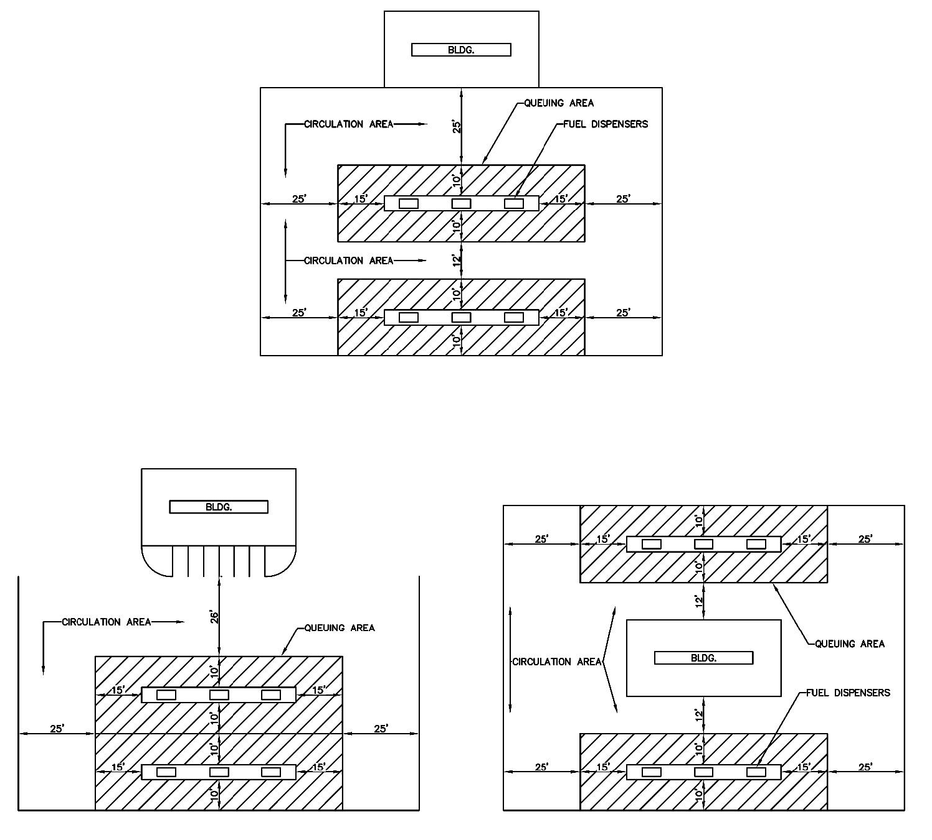
Figure 9-10 — Service Station Queuing & Internal Circulation Layout
G. Refer to Figure 9-11 for calculation of queue length required for a drive through facility.
H. Refer to Figure 9-12 for layout of queuing area and internal circulation routes on a site providing a drive through facility.
I. School sites with a gate at school driveways must be open for drop off and pick up for one hour prior to the start of the earliest class until 30 minutes after the start of the latest class and one hour prior to the end of the earliest class until one hour after the end of the latest class.
J. The provided queue area on site shall be able to accommodate the peak AM or PM hour queue length for a facility. The peak queue length shall be calculated as follows, unless otherwise required by the City Transportation Engineer or applicable Director to follow the procedure in Section 9.3.4.1.1:
1. Expected peak hour queue is assumed to be 10—15% of all arriving vehicles during the AM or PM peak hour, whichever generates the higher number of trips. Refer to Table 9-4 for example calculations of queue length.
2. The 10—15% AM or PM peak hour arriving vehicle shall be calculated using the current version of the ITE Trip Generation Manual. "AM Trips In" or "PM Trips In".
Table 9-4 — Queue Length Samples from ITE Method
Land Use (ITE Code) | Fast Food (934) | Car Wash (948) | Coffee (937) | Bank (912) | Pharmacy (881)
10% of ITE Trip Generation (AM/PM Peak) | 6 | 2 | 14 | 6 | 7
15% of ITE Trip Generation (AM/PM Peak) | 9 | 3 | 20 | 9 | 11
All numbers based on 10th Edition of ITE Trip Generation Manual. Use Latest Edition.

9.3.4.1.1 Alternative Queueing Analysis.
In lieu of the method identified in Section 9.3.4.1(J), the expected peak hour queue shall be calculated through observation of a comparable land use and building size for three sites within the City Limits. Observation and memorandum documenting results shall be done by a professional engineer licensed in the State of Texas.
Once expected peak hour queue has been determined, queuing area shall be sized to accommodate the full length of the expected AM or PM peak hour queue using the following formula:
Equation 9-1 Expected AM or PM Peak Hour Queue Length = Expected Queue × 25 feet
(25 ft. is the assumed space for one queued vehicle)
The following Figure 9-11 Illustrates the queue length calculation concept for a straight line queue, and Figure 9-12 illustrates the queue length concept for a drive through facility type with a "building wraparound" configuration.
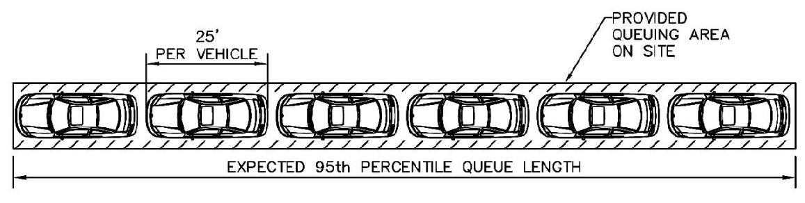
Figure 9-11 — Area for the 95th Expected Queue
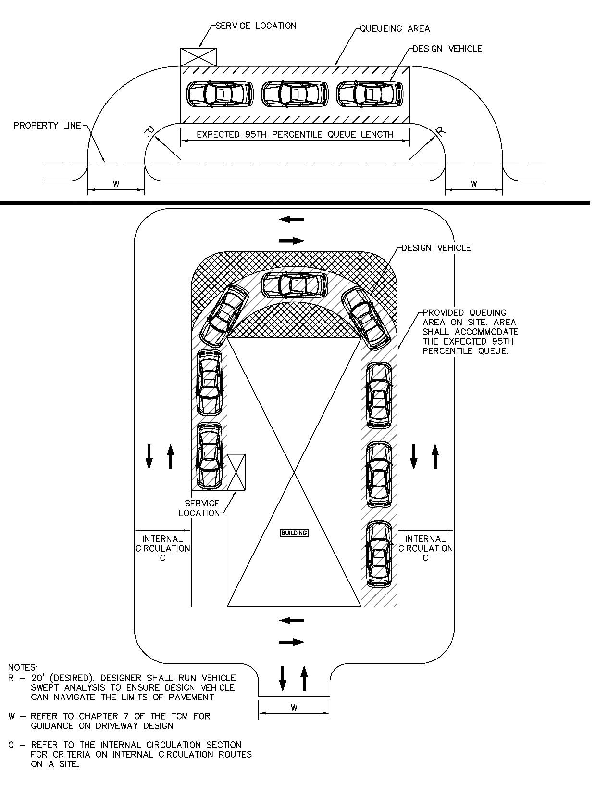
Figure 9-12 — Semicircular Drop-off Driveway & Drive Through Facility Queueing with Internal Circulation Layout

9.3.4.2 Internal Circulation Routes.
Internal circulation routes shall be designed in accordance with the following criteria:
A. Refer to the City of Austin's Fire Protection Criteria Manual for criteria on fire lanes that shall be followed when designing off-street circulation lanes. Refer to Figure 9-13 for an overview of fire lanes and circulation lanes in off-street parking lots.
B. Internal circulation and fire lane grades must also be approved by applicable departments in addition to the Fire Department approval.
C. Signs and curb markings are required to indicate "No Parking — Fire Zone." Access aisles shall be designed with an appropriate 25 ft. inside turning radius and a 50 ft. outside turning radius at turns to accommodate operational fire department apparatus. Refer to Figure 9-13 below.
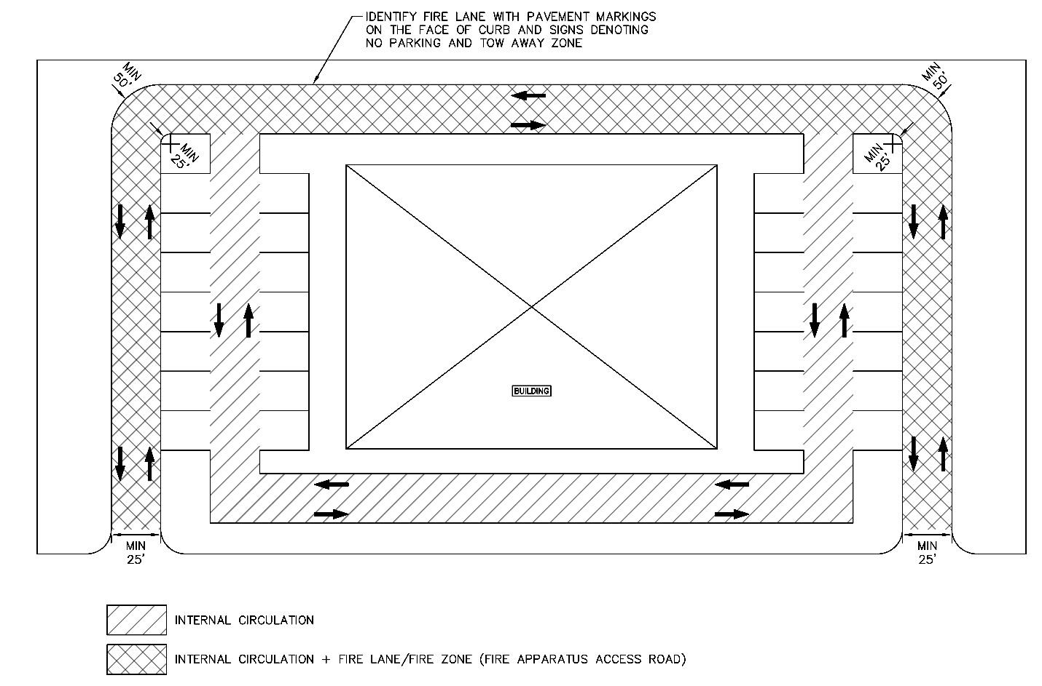
Figure 9-13 — Internal Circulation & Fire Lanes Layout
D. The minimum separation between the edge of the street pavement and the first conflict point within a parking area shall be determined according to the requirements listed in Section 7 of this manual to follow requirements for driveway throat lengths.
E. Entry driveways equipped with controlled access gates must provide a minimum of 40 ft. of storage space measured from the gate to the property line. A different storage length may be required by the City Transportation Engineer or applicable Director if a study warrants. Additional storage space may be required if indicated by a Transportation Impact Analysis in Section 10, as required by the City Transportation Engineer or applicable Director.
F. All semicircular drop-off driveways shall be designed to operate in one direction only. Figure 9-12 provides specific design criteria for semicircular drop-offs.
G. All internal circulation and queuing areas must be designed to accommodate the turning radii of the vehicles that will be using the site. Design criteria are provided in Section 3.2.1 for various design vehicles.
H. The minimum width for an internal drive or circulation aisle with no parking is 20 ft. for two-way traffic and 10 ft. for one-way traffic. Additional width, up to 25 ft. for two-way traffic and 15 ft. for one-way traffic, may be required where traffic volumes are heavy or where obstructions or circuitous alignment necessitates a wider drive for clearance of turning vehicles. Fire Department access criteria must also be met.
I. On-street parallel and head-in angle parking are allowed on an Internal Circulation Route, subject to compliance with fire access standards. If the Internal Circulation Route is intended to accommodate bicycles, head-in and angle parking is not permitted.

9.3.4.3 Driveway Throat.
The driveway throat is the section beyond the driveway into the site. This area of the driveway is used for storage of vehicles accessing and departing the site. The geometry of this area is highly dependent on the access capacity the property requires. The components that make up the driveway throat can be found in Figure 7-4 and are explained in greater detail in the sections that follow.

9.3.4.3.1 Throat Storage Length.
The throat storage length for high volume access driveways is directly related to the number of parking spaces accessible by the driveway. To determine the throat storage length, the total number of parking spaces shall be divided by the number of driveways and refer to Table 9-5. The calculation shall be used on the proposed number of parking stalls for an overall development or the number of parking spaces for an individual lot, whichever provides the more conservative ratio of parking stalls to driveways. This will ensure all departing cars can be stored adequately while waiting to exit the site.
Table 9-5 — Minimum Throat Storage Length
Parking Spaces Per Driveway | Storage Required (ft)
Parking Spaces Per Driveway | Multi-Family or Commercial Land Use |  | Industrial Land Use
Parking Spaces Per Driveway | Left Turn Allowed
Parking Spaces Per Driveway | No | Yes | No | Yes
<25 | 25 | 25 | 25 | 25
25—50 | 25 | 40 | 25 | 40
51—100 | 25 | 40 | 40 | 40
101—200 | 40 | 80 | 40 | 60
More than 200 | 100 | 150 | 40 | 100

A. Throat length is measured from the property line to an interruption point.
1. An interruption point consists of the first intersecting aisle, internal driveway, or parking stall.
B. For minor driveways that do not access a parking lot, the length of the driveway must fully incorporate the length of one parked vehicle or 20 ft.
C. For sites with structured parking, the throat length may be reduced to 0 ft. if queueing areas are demarcated to prevent turning conflicts for queued vehicles.

9.4.0 LOADING ZONES
Loading zones are defined as spaces used to load and unload pedestrians, goods serving public and private properties, and waste materials. These areas must include proper signage and pavement markings to clearly define the limits of the loading zone and convey the required use of space to all users of the public right-of-way.

9.4.1 OFF-STREET GENERAL LOADING REQUIREMENTS
Refer to LDC for requirements for off-street loading facilities. If requirements of the LDC are in conflict with these criteria, the LDC supersedes these criteria. Additional design criteria are provided in the remainder of this subsection.
A. Each off-street loading zone shall consist of a rectangular area not less than 12 ft. wide and 25 ft. long, with a vertical clearance of not less than 15 ft.
B. Loading area dimensions - shall be based on the design vehicle, which is the vehicle with the predominant use.
1. Loading Stall Length = Loading vehicle length plus 5 ft. clearance
2. Loading Stall Width = 2 ft. clear on either side of vehicle, minimum 12 ft.
C. Freight loading and trash collection facilities should be designed and located to minimize intermixing of truck traffic with other vehicular and pedestrian traffic on site. Such facilities shall be located off the main access and parking aisles and away from all pedestrian corridors, except for commercial alleys.
D. Maneuvering areas for loading facilities shall not conflict with parking spaces or with the maneuvering areas for parking stalls. Public right-of-way shall not be used for maneuvering. All maneuvering shall be contained on-site.
E. Rear-loading freight docks are preferred to side-loading docks. For such rear-loading docks, truck circulation patterns and dock positions should be designed for left-side, back-in maneuvers to allow for better driver visibility. The apron space should be adequate to allow the truck to back and pull-out in one maneuver. Where semitractor/trailer combinations are expected, the critical maneuvering and circulation areas shall be designed to accommodate trucks with a WB-62 design, except for the Downtown Austin Area as defined in Figure A-2, where a WB-40 truck design may be used. SU-40 truck design may be used for design via an administrative variance if loading is restricted to this type of vehicle or smaller.
F. Land uses where fuel is dispensed must provide an adequate maneuvering and unloading area for fuel delivery vehicles. Such facilities or areas shall be designed to enable trucks to deliver fuel without interfering with on-site parking, queuing areas, internal circulation, or driveway access.
G. For sites meeting the requirements for off-street loading in LDC with greater than 100,000 square feet of gross floor area, one of the following shall apply:
1. An analysis shall be performed by an engineer licensed in the State of Texas as part of a Transportation Impact Analysis, per Section 10, if required per LDC, to determine the number of required loading spaces based on arrival schedules for deliveries to the site. The amount of loading spaces provided shall ensure that adequate spaces exist for the peak loading times.
2. If a Transportation Impact Analysis is not required, then loading spaces shall be provided per the LDC.
H. Loading spaces may be shared by multiple land uses or a single building as a common loading space if the City Transportation Engineer or applicable director determines that the loading space can adequately serve each use.
I. Common loading zones, which are shared by several properties along the corridor shall be provided whenever loading zone demand allows. Maximum frontage that may share a common loading zone shall be limited to 600 ft. of shared frontage between adjacent properties.

9.4.2 ON-STREET LOADING
This Section defines criteria that shall be followed for on-street loading zones. On-street loading zones shall not be allowed without applicable staff approval and a waiver. There will be no compensation for the removal of on-street loading. On site loading zones shall be provided unless applicable staff determine it is not feasible and allow for on-street loading or shared loading zones with adjacent sites.

9.4.2.1 Types of On-Street Loading Zones.
A. Commercial - For commercial service delivery vehicles that meet the definition in Chapter 12-5-5 of the City Code. These zones are limited to 30 minutes. These are allowed on Level 0, 1, 2, and 3 Streets in designated loading spaces. Time limits for loading shall be signed for these spaces and conform to City of Austin Standards and be approved by the City Traffic Engineer, applicable director, or their designee.

9.4.2.2 On-Street Loading Zone General Criteria.
A. Loading zone widths shall be a minimum of 8 ft., if placed adjacent to on-street parking stalls they shall be the same width. Loading zone spaces shall be a minimum 25 ft. in length.
B. Passenger loading zones shall comply with all Public Right-of-Way Accessibility Guidelines (PROWAG) as well as the current Texas Accessibility Standards (TAS). If a loading zone is desired for an adjacent land use, additional right-of-way must be dedicated by applicant to accommodate access aisles and curb ramps provided for access to spaces.
C. Wherever Level 0 Streets are behind a site, loading activities may take place on the Level 0 Street with applicable waiver.
D. An accessible pedestrian path per Section 9.3.3, compliant with PROWAG and TAS shall be provided between the site and loading zone.

9.4.2.3 On-Street Loading Zone Placement.
Loading zones shall be clearly marked and identified within the right-of-way. This ensures that all users of the right-of-way can clearly differentiate between loading and non-loading zones. The criteria below shall be followed for the placement of on-street loading zones.

9.4.2.3.1 Curb Side Loading Zone Placement Criteria.
A. The loading zone shall be placed outside of the adjacent moving lanes of traffic. Where on-street parking is present, loading areas can be created by restricting the parking in these areas.
B. Loading zones shall be placed at the start or end of on-street parking stalls along the street if applicable.

9.4.2.3.2 Loading Zone Placement in Relation to Bike Lanes.
A. Loading zones shall not be placed within the limits of a designated bike lane. Bike lanes shall remain clear of obstructions as not to require bike lane users from maneuvering into traffic lanes.
B. If approved, loading zones shall be placed between vehicular travel lanes and bike lanes.

9.5.0 SHARED-USE PARKING
Shared-use parking shall be applied for and evaluated through a Transportation Demand Management (TDM) Plan as a component of such studies required for site development. For applicants desiring to reduce off-street parking or loading requirements through shared-use parking on a site which does not require a TDM Plan, the applicant may submit a TDM plan for the site per the procedures identified in Section 10 of this manual.

9.5.1 GENERAL REQUIREMENTS

9.5.1.1 Site Plan.
All requests for shared parking must be accompanied by a site plan and include sufficient information to identify the type and intensity of the uses which are proposing to share parking.
For projects which are subject to site plan review only because of a request for shared parking, the City Transportation Engineer or applicable Director may modify the normal site plan submittal requirements if some material is determined to be unnecessary.

9.5.1.2 Ownership.
When first approved, the shared parking facility must be under common ownership or under the control of a single site plan. All requirements and conditions imposed upon the shared parking facility shall be listed on the site plan and shall be binding upon all subsequent purchasers.

9.5.1.3 Time of Submittal.
All requests for shared parking must be submitted in writing at the same time as an application for site plan review. For Commission-approved site plans, any supplemental information required by the staff in order to complete the review must be submitted at least 18 working days prior to the date on which the project is scheduled for consideration by the Planning Commission.

9.5.1.4 Review Criteria.
All requests for shared parking shall be reviewed by the City Transportation Engineer or applicable Director in accordance with this Section or applicable requirements of a TDM Plan in Section 10. The City Transportation Engineer or applicable Director shall determine whether shared parking is feasible at the proposed site and specifying the reasons for approval or disapproval.

9.5.2 SUITABLE APPLICATIONS OF SHARED PARKING

9.5.2.1 Uses.
The project must contain at least 2 of the following uses which are functionally and physically related:
1. Office
2. Retail
3. Restaurant
4. Cinema
5. Residential
6. Hotel
7. Cocktail Lounges
8. Religious Institutions
9. Recreational
10. Financial Institutions
11. Public Primary or Secondary Educational Facility
For projects which: 1) contain other land uses; or 2) have operating hours which do not overlap, shared parking may be considered if the applicant furnishes reliable data signed by a professional engineer registered in the State of Texas or other state-licensed professional with training or experience in the design of parking facilities and/or shared parking documenting: 1) the appropriateness of shared parking in similar situations; or 2) modifications to the ULI methodology. Nevertheless, site plan characteristics, public transit availability, adequacy of roadways and access, the methodology in Section 9.5.3, the design strategies in Section 9.5.4 below and the land uses selected are the primary variables used in determining the appropriateness of shared parking.

9.5.3 METHODOLOGY

9.5.3.1 Responsibility.
The preparation of a proposal for shared parking shall be the responsibility of the applicant. A preapplication consultation with Transportation Review staff is encouraged. A shared parking proposal must be prepared by a professional engineer registered in the State of Texas or other state-licensed professional with training or experience in the design of parking facilities and/or shared parking.

9.5.3.2 Analysis Methodology.
A proposal for shared parking shall be based upon the current edition of Urban Land Institute's (ULI) "Shared Parking" Report or upon other methodologies approved by the City Transportation Engineer or applicable Director. Applicants should refer to the Shared Parking report for a complete discussion of the variables analyzed. Any methodology other than the ULI procedure shall be thoroughly documented in a similar level of detail by a professional engineer registered in the State of Texas prior to review of the parking analysis by the staff. The City Transportation Engineer or applicable Director shall determine the appropriateness of other methodologies for each specific application.

9.5.3.3 Total Parking Reductions.
Regardless of the methodology, City of Austin parking requirements contained in LDC shall be the minimum acceptable rates for calculating peak parking requirements for each use. Refer to LDC for criteria on allowable reductions to the parking requirement for a site before performing a shared parking plan or TDM Plan including shared parking. Reductions in the total parking requirement may be made to reflect different hours of operation; different hourly, daily, or monthly peaks; interaction among land uses; or incentives for use of transit or carpooling, as outlined in ULI "Shared Parking Report".

9.5.4 SHARED PARKING PLAN REQUIREMENTS
The following are required to be demonstrated as part of a plan designating parking spaces for shared use between different land uses.

9.5.4.1 Distribution of Spaces.
All shared parking facilities shall be accessible to all land uses and adequately distributed on the site to provide the required parking for any use within the site. To be considered shared parking, an accessible pedestrian route per the provisions of PROWAG and TAS must be provided from parking to all land uses.

9.5.4.2 Reserved Spaces.
Parking stalls which are reserved for employees or other individuals shall not be included in shared parking unless hours of use are such that parking is available for others to use at different hours.

9.5.4.3 Fees and Access Controls.
Any parking fees and any access controls to a parking area (such as gates or attendants) shall be identified in the shared parking plan.

9.5.4.4 Hours of Operation.
For projects using the ULI report, the hours of operation shall be consistent with the ULI peak hour methodology.

9.5.4.5 Accessible Parking.
Spaces designated for accessible use shall be provided in a quantity equal to the sum of the minimum requirements for each individual use in the mixed-use development as set forth in the LDC. Accessible parking stalls may not be included in parking stalls designated as shared.

9.5.5 SHARED PARKING PLAN REVISIONS

9.5.5.1 Change in Uses.
After a shared parking facility has been approved, any subsequent change, addition, or deletion in the type or intensity of the original mixed land uses which results in an increase in the parking requirement shall require an updated shared parking plan or TDM plan demonstrating accommodation of the increased parking demand as part of the change in use. No certificate of occupancy for the new or changed uses shall be issued without site plan approval for the revised shared parking facility or, absent such approval, the provision of sufficient parking stalls to match the sum of the minimum requirements for each individual use.

9.5.5.2 Change in Operations or Design.
After a shared parking facility has been approved, any subsequent change in operations affecting hours of operation by a change of 1 hour or more or design impacting accessible routes or use of parking stalls deviating from the plan, shall require administrative approval by the City Transportation Engineer or applicable Director. In approving such revisions, the City Transportation Engineer or applicable Director must determine that the circumstances and conditions applicable at the time of the original approval remain valid, and that the changes would not affect the suitability of the site for shared parking. The City Transportation Engineer or applicable Director will determine submittal requirements for each revision based upon the nature of the change requested.

9.5.6 MONITORING
In order to ensure adequate parking capacities and establish a database for better evaluating the adequacy of shared parking, all projects approved for shared parking will be required to conduct a follow-up evaluation of the actual utilization of the parking facility. Such an evaluation shall be signed by a professional engineer registered in the State of Texas or other state-licensed professional with training or experience in the design of parking facilities. The study shall be performed in accordance with standards established by the City Transportation Engineer or applicable Director, as outlined in this Section. The evaluation shall be conducted following completion and occupancy, of the project within a time period specified at the time of approval, depending on phasing, project size, occupancy and utilization. The study shall take into account any variations due to building occupancy rates and hourly, daily, or monthly peaks in parking utilization.
In the event that the evaluation is not submitted within the agreed-upon time frame or identifies a deficiency in the number of parking spaces needed to satisfy the demand, the City Transportation Engineer or applicable Director will notify the owner that no additional permits will be issued for changes in occupancy until the parking supply is brought into compliance with the demand. The owner may correct the deficiency through provision of additional parking spaces, a change in the tenant mix, changes in the operating hours or use of other strategies approved by the City Transportation Engineer or applicable Director.

9.5.6.1 Procedures for Monitoring of Shared Parking.
A follow-up evaluation of an approved shared parking application shall contain the following elements:
A. A site plan including an inventory of all parking provided on the site, identifying the quantity of stalls in each parking area.
B. An inventory of all uses on the site as shown on the site plan, identifying gross square footage of floor area, type of business, normal operating hours, and any unoccupied floor space at the time of the inventory.
C. An hourly count of all vehicles parked on the site, beginning one hour before the earliest opening hour of a business within the project and ending one hour after the latest closing hour, with the condition that no counts need be taken before 6:00 a.m. or after 12:00 midnight. To substantiate the peak day, these counts must be taken on three different weekdays and on one Saturday as specified by the City Transportation Engineer or applicable Director. Counts must not be taken on days with inclement weather. The data must identify the number of vehicles which are illegally parked outside designated parking stalls (within right-of-way, in aisles, in loading zones, etc.).
D. Documentation of any existing transit usage or ridesharing programs.
E. Adjustment of the empirical data to represent the peak hours, days, and months, using the factors contained in the current edition of the Urban Land Institute's Shared Parking report, as well as compensation for transit usage. Adjustments for internal capture or auto occupancy may be made only if supported by empirical data.
F. An assessment of the adequacy of the available shared parking at the peak periods identified in the Shared Parking report for the uses contained in the project.
G. Recommendations for addressing any deficiencies identified in the parking supply.

9.6.0 CALCULATION OF PARKING REQUIREMENTS
The final parking requirements on a site shall be determined by the Land Development Code and any applicable reductions allowed for through a TDM plan or shared parking analysis, per Section 9.5.0 and shall comply with the criteria outlined in this manual. LDC establishes parking requirements for all land uses based on the applicable zoning in the City of Austin. LDC establishes parking reductions allowed for within the City of Austin. In addition to LDC, a TDM Plan, described in Section 10 of this manual, may further reduce parking required on a site. Maximum parking allowed for specific zoning is calculated prior to any applicable parking reductions in the Land Development Code or this manual.

9.6.1 ON-STREET PARKING COUNTED TOWARDS PARKING REQUIREMENT
The minimum off-street parking requirement shall be reduced by one stall for each on-street parking stall located adjacent to the site in a public street right-of-way. Refer to Section 9.2.0 for on-street parking criteria. On-street parking counted towards parking requirements remain open to the public and may not be reserved for sole usage of the adjoining development. The adjacent on-street parking may be removed at any time for any reason and the developer counts the spaces at their own risk.

9.7.0 PARKING LIFTS

9.7.1 PARKING LIFTS TYPES
A. A mechanical lift or vehicle elevator is defined as an automated mechanism that lifts parked vehicles to create additional parking space below.
B. A robotic parking system is defined as an automated lift using an elevator system that moves vehicles from an entrance area to a separate storage area within the parking facility.

9.7.2 PARKING LIFTS GENERAL CRITERIA
A. Parking lifts may be used to meet the parking requirements for a site for the following land uses:
1. Multifamily Residential
2. General Office
3. Industrial Park
4. Commercial (Hotel)
5. Automotive
6. Institutional
B. The location of mechanical lifts shall be located within an enclosed parking facility. All lifts and equipment shall not be visible from public view from outside of the facility.
C. Mechanical parking lifts shall not be used for accessible parking spaces.
D. Use of mechanical parking lifts shall be approved by the City Transportation Engineer or applicable Director prior to being installed in a parking facility. To be approved, an application shall be submitted by a professional engineer licensed in the State of Texas. Application shall include the following information:
1. Operation plan, hours of operation, number of staff members for vehicle drop off and retrieval, and plan for maintenance and emergency support.
2. Layout of mechanical lift placement within the parking structure and provided vehicle queueing area for stacking of vehicles during vehicle drop-off and retrieval.
3. Vehicle drop-off and retrieval efficiency during the expected peak hour shall be provided.
E. Mechanical parking lifts shall not encroach into the limits of internal circulation lanes or adjacent parking stalls.
F. Parking lifts adjacent to parking stalls shall maintain adequate clearance from parked vehicles at all times.
G. All parking lifts shall be designed to prevent lowering of the lift when a vehicle is parked below the lift.
H. All mechanical parking systems, including lifts, elevators and robotic systems, must be inspected and certified as safe and in good working order by a licensed mechanical engineer at least once per year and the findings of the inspection shall be summarized in a report signed by the same licensed mechanical engineer or firm.

9.8.0 BICYCLE PARKING
Bicycle parking standards ensure that required bicycle parking is easy to access, convenient and secure. The standards allow for a variety of bicycle parking facilities which may serve a wide range of uses. Bicycle parking space supply and location shall not conflict with requirements of the LDC. Additional measures to enhance connectivity to bicycle parking shall be provided as required by LDC. For detailed specifications of bicycle parking equipment, see the Standards Manual. Table 9-6 specifies how to determine the amount of short- and long-term bicycle parking based on land use as a proportion of total bicycle parking required by the LDC.
The bicycle parking standards specified in this Section refer uniquely to bicycle parking for privately owned bicycles and do not refer to shared micromobility or dockless mobility parking. Dockless mobility parking placement shall follow Section 9.9.0 of this manual.
Table 9-6 — Short- and Long-term Bicycle Parking Spaces by Land Use
Use Classification | Percentage of Overall Required Bicycle Parking
 | Short-term bicycle parking | Long-term bicycle parking
Residential | 30%—50% | 50%—70%
Commercial
Commercial, general | 70%—100% | 0%—30%
Business and professional offices | 10%—30% | 70%—90%
Industrial | - | -
Civic
Civic, general | 70—100% | 0%—30%
College and university facilities | 60%—80% | 20%—40%
Public or private primary and secondary educational facilities | 70%—90% | 10%—30%
Agricultural | - | -

9.8.1 BIKE PARKING LOCATIONS
Bicycle parking locations and placement are split into short-term and long-term bicycle parking categories. The amount of each type of parking shall be determined based on building use and available data, including trip generation rates, employees per square footage, number of residential units, and visitation rates and in compliance with the Land Development Code bike parking required.
The following criteria apply to all bicycle parking:
A. Provide enough space between bike rack locations to adequately accommodate a bicycle locked in every spot. One "U" rack provides two bike parking spots.
B. The standard required bicycle space is 2 ft. wide, 6 ft. long and 3 ft. 4 in. tall. See Figure 9-14. If larger styles of bicycles such as cargo or electric bicycles are anticipated, the design shall accommodate the footprint of these bicycles as the design bicycle (up to 3 ft. wide by 10 ft. long).
C. Bike parking shall be accessible by the street and at Street Level.
D. Bike parking locations shall be outside of the travel lanes, loading zones and bike lanes.
E. Bicycle parking may be installed in the pedestrian zone or bicycle and street edge zone wherever feasible, and if applicable, within the tree and furniture zone. Bicycle parking must allow a pedestrian path clearance per Section 4.1.1 (A) when bikes are locked to the racks per intended design use. The accessible pedestrian path shall meet current PROWAG and Texas Accessibility Standards (TAS). Figure 9-15 illustrates permissible locations for bike rack placement.
F. Bike racks may be installed parallel, perpendicular or at a 45—60-degree angle to the curb, as appropriate. Figure 9-16 and Figure 9-17 illustrate required bike rack spacing.
G. When it is not possible to locate bicycle parking in the pedestrian zone, parking areas shall be separated from motor vehicle traffic with either a raised curb or bollards.
H. Bike rack placement in the pedestrian zone shall meet permissible spacing criteria as shown in Section 4.
I. Must be located in a well-lit area.
J. Must be at Street Level. Bike parking shall not be installed on elevated sidewalks or in other topographically challenging scenarios and be accessible from the nearest bike facility.
K. All bicycle parking shall have an accessible pedestrian path connecting bicycle parking spaces to the entrance of a development per requirements of LDC.
L. If bicycle parking is provided outside of public right-of-way or easements or provided in a structured parking garage, an accessible path to bicycle parking from the site entrance shall be provided.
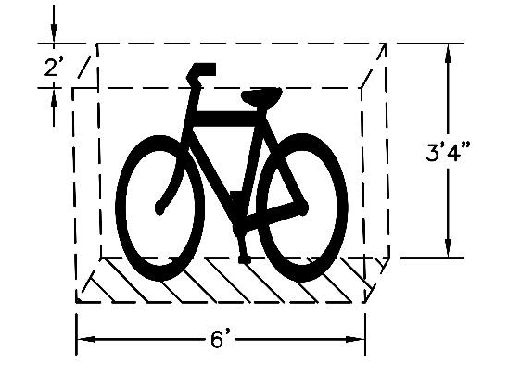
Figure 9-14 — Standard Bicycle Space
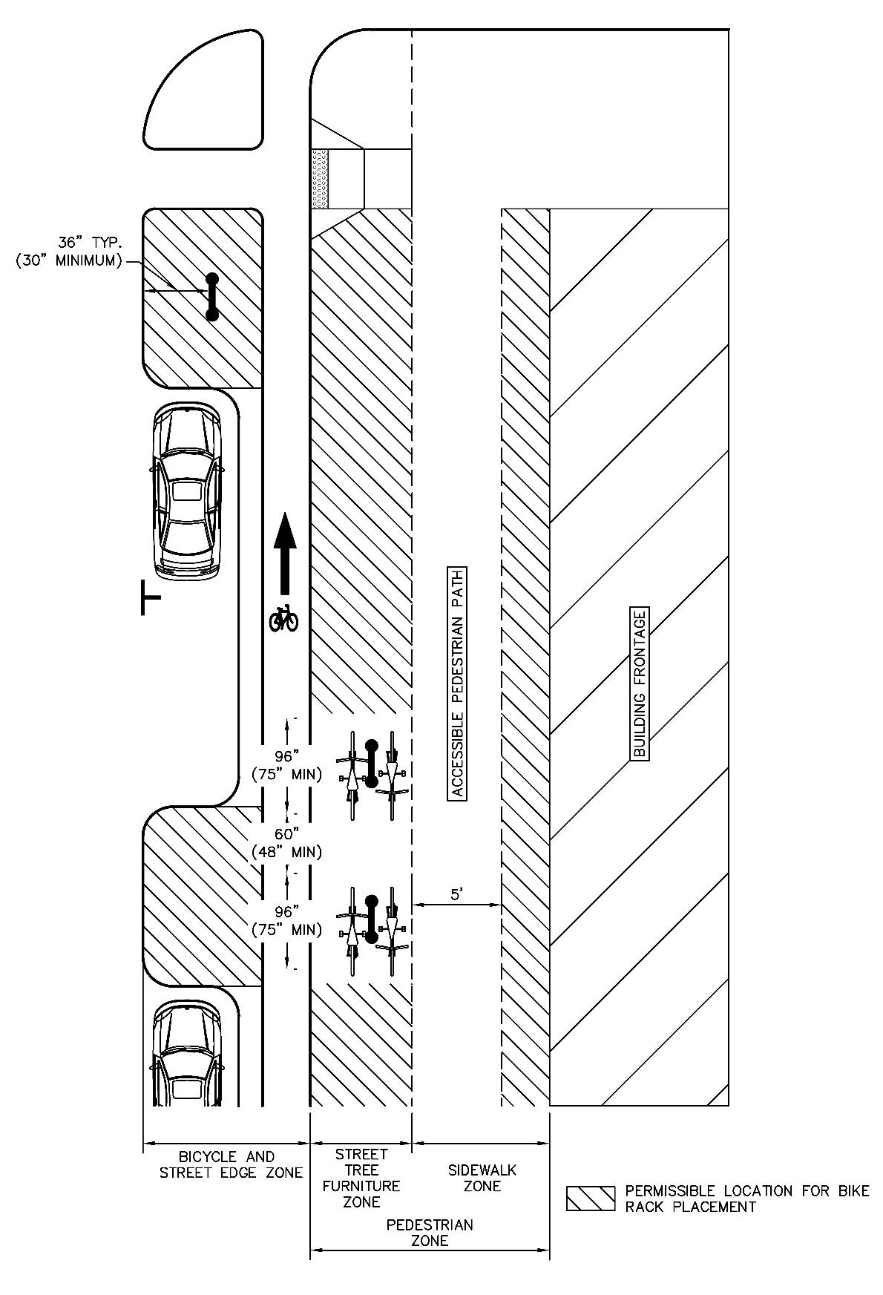
Figure 9-15 — Permissible Locations for Bike Rack Placement
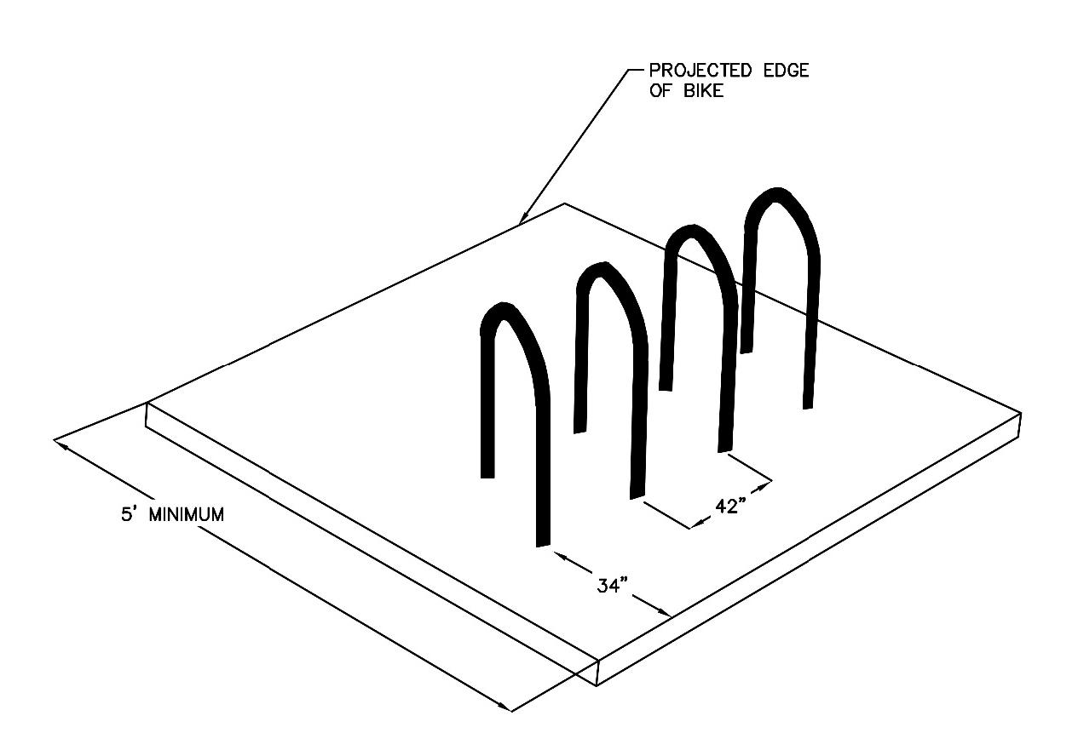
Figure 9-16 — Bike Rack Spacing (Away from Vertical Obstructions)
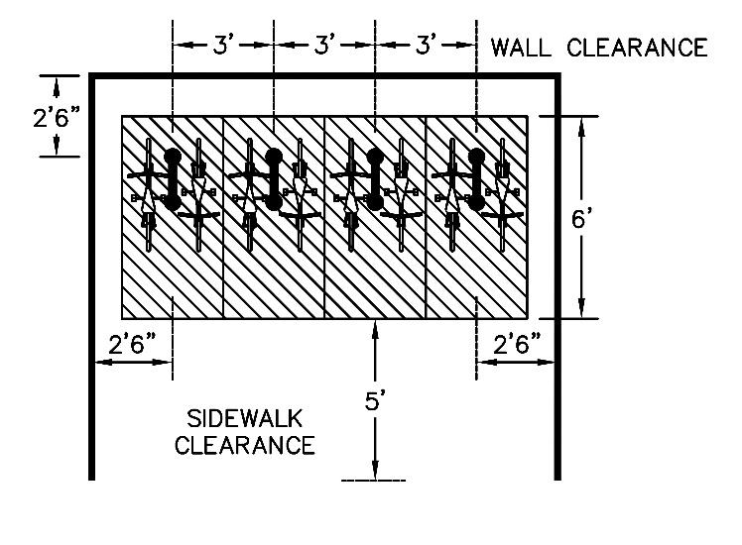
Figure 9-17 — Bike Rack Spacing (Near Vertical Obstructions)

9.8.2 SHORT-TERM BICYCLE PARKING
Short-term bicycle parking serves people who park their bicycles for less than 4 hours in a publicly accessible and convenient location. This type of bicycle parking encourages shoppers, customers, patients, and other visitors to use bicycles as a mode of transportation by providing visible, convenient, and secure parking.
Required short-term bicycle parking must meet the following standards:
A. Shall be located at ground level within 50 ft. of the principal building entrance.
1. For sites with more than one primary building, the required bicycle parking shall be dispersed at principal entrances of all primary buildings.
B. Shall be publicly accessible.
C. Shall be visible from the lobby or windows of the building.
D. Shall not compromise pedestrian access or mobility.
E. If possible, protected from severe weather, including full sun or rain, by existing structures, such as overhangs or awnings, or by natural elements such as tree canopy.
F. All public entrances must have at least 2 bicycle parking spaces unless this exceeds the total requirement from the Land Development Code.
G. Short-term bicycle parking is typically placed within the right-of-way, near the curb or near building entrances. Good bike parking placement allows for easy access to the parking by bicyclists without impeding other users of the right-of-way and without placing the bike or bike rack in undue risk from moving traffic. See Figure 9-15 for permissible bike rack placement in the right-of-way.

9.8.3 LONG TERM BICYCLE PARKING
Long-term bicycle parking serves people who park their bicycle for 4 or more hours and requires more secure parking. This type of bicycle parking encourages residents, transit users, employees, and students to use bicycles as a mode of transportation by providing secure, convenient, and weather-protected parking.
Required long-term bicycle parking must meet the following location criteria:
A. Shall be located in a secure location within 250 ft. in a walked path of building entryways, or within a building, or in a covered motor vehicle parking space within 250 ft. in a walked path of a Street Level entrance without use of an elevator.
B. Long-term bicycle parking must be no farther than the closest motor vehicle parking space in that location, excluding accessible parking spaces.
C. At least 50% of required long-term bicycle parking must be provided as standard U racks or spaces on lower level of stacked bicycle parking racks that do not require lifting or upper level of stacked bicycle parking racks with lift assist. See Figure 9-18 for example layout of a bike locker room. See Figure 9-19 for a typical layout of a two-tier lift assist rack.
D. All long-term bicycle parking shall be covered to provide weather-protected parking.
E. A detail of the bicycle rack designs, locations, and accessible path must be included on site plans.
F. Bicycle Cages and Bicycle Storage Room parking areas must be easy to access to a person walking, not carrying, a bicycle, including:
1. No heavy or sprung doors that must be held open for access,
2. No stairs that would require bicycles to be lifted to access the area,
3. No blocked or restricted areas that would be cumbersome to walk a bicycle through, for example bicycle racks, pull-out trays that block entrances, or hairpin corners,
4. No bicycle racks or pull-out trays that interfere with the operation of an adjacent rack,
5. Bicycle parking must be located in a well-lit area with a minimum average illumination level of 200 lux (recommended light levels from the US General Services Administration for public areas including stairwells, pedestrian tunnels and elevator lobbies),
6. Provide electrical outlets for electric bicycle charging,
7. Consider designing at least 5% of required spaces for large bicycles, such as cargo, recumbent, tandem, electric and bicycles with trailers. The larger bicycle footprint design is typically 3 ft. by 10 ft., and
8. The bicycle cage or storage room may be secured by key, smart card, fob, or code access. If so, the bicycle parking area shall be accessible to designated users at all times.
G. Mobility hubs, as defined by Capital Metro Transit Authority (CMTA), shall provide weather-protected, high security parking such as bike lockers, bike shelters or bike cages.
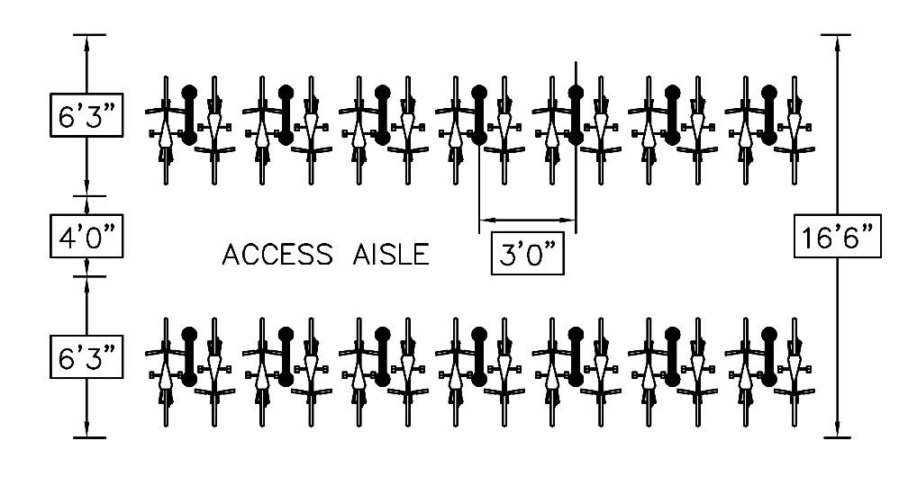
Figure 9-18 — Typical Bike Room Layout
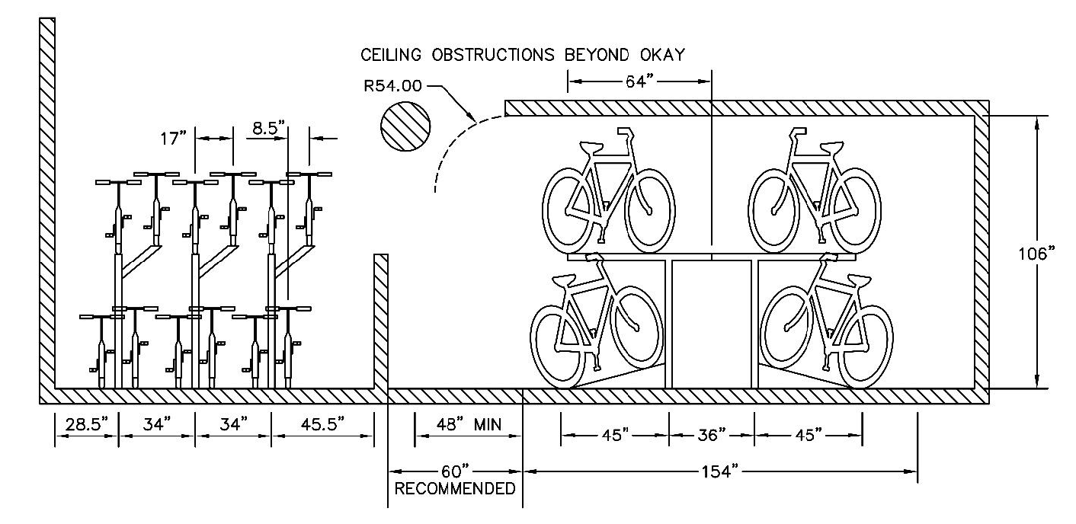
Figure 9-19 — Typical Tow-Tier Lift Assist Rack Layout

9.8.4 BIKE PARKING EQUIPMENT AND INSTALLATION REQUIREMENTS
The City of Austin hereby adopts the latest edition of the Association of Pedestrian and Bicycle Professionals (APBP) Bicycle Parking Guidelines. The following criteria apply to all bicycle parking:
A. Bicycle racks, lockers or other parking types must be securely anchored with the appropriate fastener according to ground or wall surface material.
B. Bicycle parking installed on concrete, such as the standard "U rack", shall be securely anchored with tamper-resistant hardware, preferably a tri-groove security nut or a crimp anchor.
C. Area devoted to bike parking shall be hard surfaced.
D. If the bike rack is a horizontal rack, it shall support the bicycle at two points, including the frame of the bicycle.
E. A detail of the appropriate bike rack shall be included on the site plan.
F. Install bike storage structures per City of Austin Standard Details.
G. Artistic bike parking may be permitted after review by applicable staff.

9.8.5 PERMISSIBLE BICYCLE PARKING TYPES
When bicycle parking is short-term parking, the following parking types shall be used:
A. A "U rack" - an inverted u-shaped rack that provides parking for up to two bicycles. Typically, U racks are installed on concrete, in which case the tri-groove security nut is the recommended tamper resistant hardware. For specifications for the standard U rack see City of Austin Standard Details.
When bicycle parking is long-term parking, the following parking types, or short-term parking types, shall be used:
A. A bike locker - a fully enclosed and secure box enclosure which can hold one individual bicycle that may be accessed with a key or code. Bike lockers may be located at transit centers, parking garages or outside of buildings. See Figure 9-20 for bike locker typical layout. Additional specifications are included in the City of Austin Standard Details.
B. Locked storage rooms and cages - include a variety of configurations where a secured room provides dedicated, shared space for high volume bicycle parking. Typical access control to these rooms or cages is with a key, keypad or cardkey. These are typically located in a private office building, multifamily residential building, or mobility hubs. Bicycle racks may be standard U racks or two-tiered, vertical racks. Two-tiered racks must include a lift assist mechanism. See Figure 9-18 and Figure 9-19 for examples of bike rooms and two-tier lift assist racks.
When bicycle parking is non-standard bicycle parking using creative bicycle racks, applicable staff must provide approval on submitted design. Creative bicycle rack submitted designs must, at a minimum, include material and finish, dimensions, installation method including tamper-resistant hardware, and an image of the proposed design. The following additional design criteria apply to creative bicycle racks:
A. Must be detectable by visually impaired person using cane to navigate.
B. Must not obstruct pedestrian clear width per Section 4.
C. Must be lockable using a standard U-lock with the rack.
D. Must be able to rest the bicycle frame against rack at two points of contact.
E. Minimum height of 32 in.
F. Standard width is 20—24 inches, but this may be altered with applicable staff approval.
G. Advertising, such as a company name or logo, is not allowed.
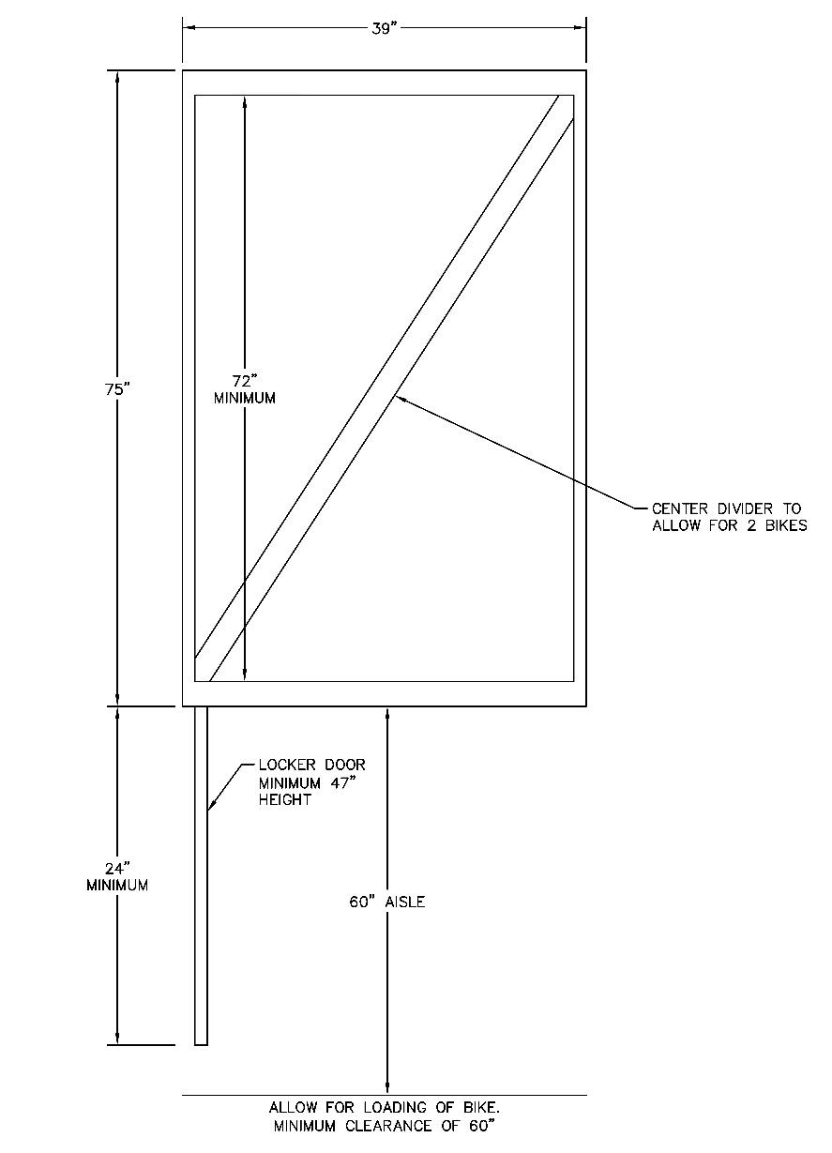
Figure 9-20 — Bike Locker Typical Layout

9.9.0 DOCKLESS MOBILITY PARKING
In general, the applicable requirements of Section 9.8.1 shall apply for placement of dockless mobility parking areas within public right-of-way or easements, maintaining an accessible path from parking to site entrances and spacing from other objects in right-of-way and easements per Section 4.2.2 of the TCM for location of streetscape furnishings. City of Austin Standard Details should be referenced for layout and installation of dockless mobility parking areas.

